Ramsgate Town Walk – Town Rounders accessibility guide
Table of Contents
Ramsgate Town Walk – Town Rounders accessibility guide 1
About this guide 2
Google Maps 360 View 2
How to use what3words 2
Accessible Parking 4
Accessible Toilets 5
Changing Places 8
Route Description 9
Loop 1 – The Royal Harbour & Riviera Vibe 9
Loop 2 – Regency Elegance & Historic Homes 15

About this guide
This accessibility guide is an accompaniment to the following guides which describe the route:
- Ramsgate Town Walk - Town Rounders - Explore Kent
- Town Rounders Regency, Royal & Riviera Ramsgate Town Walk-Explore Kent

This guide provides an overview of accessibility features and potential barriers along the route. While we have highlighted key considerations, it is not possible to include every example of every barrier. Please take care and plan thoroughly before setting out, especially at different times of the year when conditions, surfaces, and access to facilities may change. The route is shared with cyclists and joggers, so extra care is always needed. As the route follows the coastline, weather can be changeable, so it is advisable to check the local forecast before beginning your journey. Some sections may include hazards such as low walls, steep drops, and areas near water, so caution is always required. Loop 1 contains sections that run alongside the water with very steep drops that do not have barriers.
If you would like to convert this guide into an alternative format, RoboBraille is a free service that converts documents into accessible formats, including audio, Braille, and e-books.
My Computer My Way is an online guide by AbilityNet that helps people customise their devices for better accessibility, offering step-by-step instructions for Windows, macOS, iOS, Android, and browsers.

Google Maps 360 View
To learn more about the surroundings along this walk, you can explore the 360 degree Google Map for English Coast Walk: Ramsgate to Dover Town. This resource provides a good sense of the landscape and features you’ll encounter.

How to use what3words
As recommended by the Royal National Institute of Blind People (RNIB), key locations have been given using what3words. what3words is a global addressing system that divides the world into a grid of 3m x 3m squares, assigning each square a unique combination of three words to make locations easy to find and share.
- Get the App or Website
  - Download the what3words app (iOS/Android) or go to what3words.com.
- Find Your Location
  - Use the map or search bar to find where you are or where you want to go.
  - Zoom in and tap the exact spot.
- Get the 3-Word Address
  - Each 3m x 3m square has a unique address like ///apple.orange.banana.
- Navigate
  - Tap “Navigate” to open directions in Google Maps, Waze, or other apps.
- Share
  - Copy the three words and share them via text, email, or social media.
Overview
The Ramsgate Town Rounders walking trails consist of two scenic loops designed to showcase the town’s rich history, architecture, and coastal charm. Both Loops begin in a similar area, so the following facilities information is useful for both Loops.
- Loop 1: 1.4 miles (45 mins), mostly flat, marina and harbour-side.
- Loop 2: 2 miles (1 hour), includes town squares, historic buildings, and parks with some varying surfaces and gradients.
By car: Follow A299 and Military Road into Ramsgate to reach Royal Harbour.
Parking: Parking is available on Military Road and along Harbour Arm.
Train: Nearest station: Ramsgate (1 mile)
National Rail Enquiries: 03457 48 49 50
Bus: Thanet Loop (every day) 5 other services available.
Travelline: 0871 200 22 33
Use Kent Connected to plan your journey.

Accessible services and facilities for visitors to Margate, Broadstairs and Ramsgate
- Accommodation.
- Accessible Beaches and Bays.
- Car Parking and Public Transport.
- Mobility Hire and Services.
- Public Conveniences.
For more information about Ramsgate and all the local area has to offer, you can pop into the Visitor Information Centres where the local staff will be happy to help. Ramsgate Visitor Information Centre, The Custom House, Harbour Parade Ramsgate CT11 8LP 01843 598750 Open 10am - 4pm.
Thanet Visitor Information Centre For more things to do and places to stay in Ramsgate, Broadstairs and Margate.
Droit House, Stone Pier Margate CT9 1JD 01843 577577
Visit Thanet
Open 10am - 5pm
For more things to do and places to stay in Kent, the Garden of England, go to Visit Kent.

Accessible Parking
Below are car parks that are most closely related to the route. A full list of car parks, accessibility information, opening times and charges can be accessed via Thanet District Council’s Accessibility Information web page and Further information about accessible parking spaces, opening hours and charges.
The car parks nearest the start do not have specific accessible parking and Disabled Blue Badges are not exempt and payment must be made:
- Pier Yard Car Park (Harbour Parade)
  - 24 spaces
  - what3words: ///early.survey.chip
- Harbour Parking, Military Road Car Park, Ramsgate
  - 16 spaces
  - what3words: ///extra.privately.apples
The following car parks have disabled bays:
- Albion Place Car Park, Ramsgate
  - 20 spaces including 2 disabled bays
  - what3words: ///monks.fills.store
- Marina Esplanade Car Park, Ramsgate
  - 244 spaces including 2 disabled bays
  - what3words: ///point.soup.spaces
- Royal Harbour Multi-storey Car Park, Ramsgate
  - 394 spaces including 22 disabled bays
  - what3words: ///sand.length.parade

Accessible Toilets
Below are toilets that are most closely related to the route. A full list of toilets in Thanet including accessibility information and opening times for toilets in the wider area can be accessed on Thanet District Council’s information about public toilet facilities in Thanet.
- East Pier Yard
  - what3words: ///most.figure.taker
  - RADAR key required.
  - Left-hand transfer.
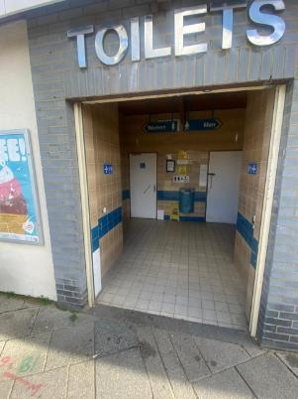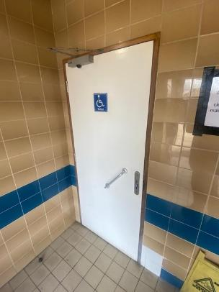
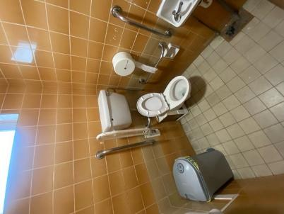
- Cavendish street
  - what3words: ///lines.pinks.metro
  - RADAR key required.
  - Left-hand transfer.
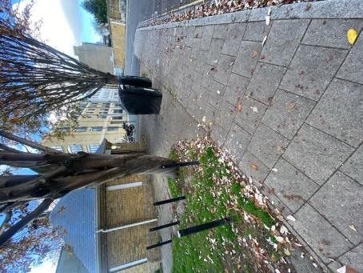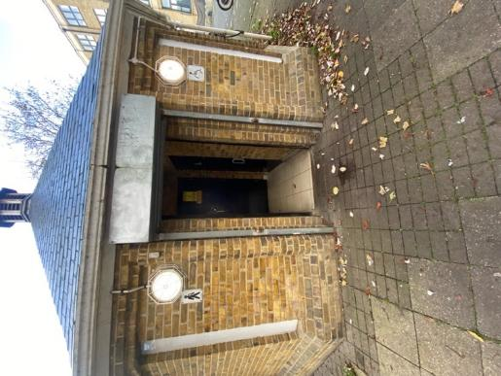
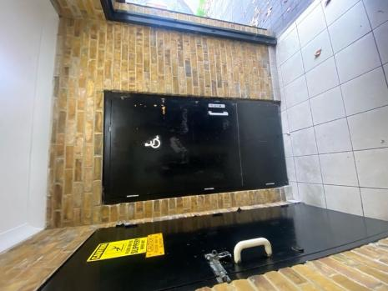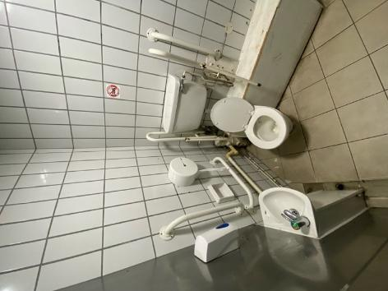

- Screaming Alley
  - what3words: ///worm.undertone.towels
  - RADAR key required.
  - Left-hand transfer.
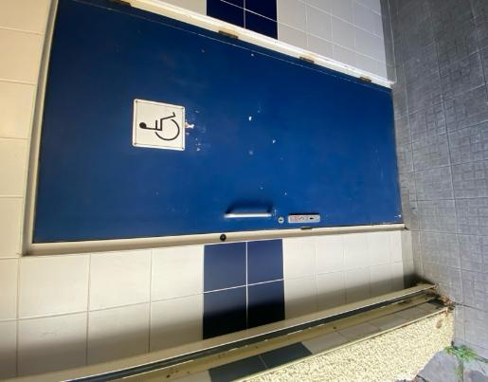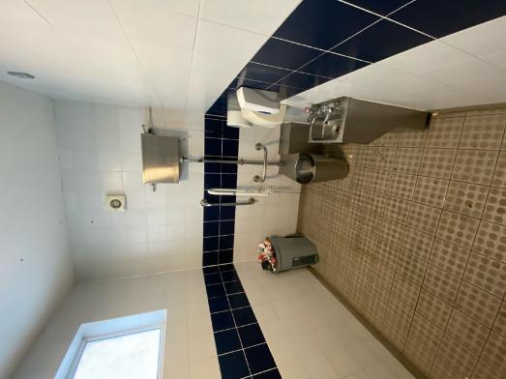

Changing Places
- Royal Victoria Pavilion (JD Wetherspoon), Ramsgate
- Located to the right on entering via Harbour Parade main entrance.
- what3words: ///reason.ruins.angle
- RADAR key required or ask staff who hold a key.
- Bench - Height Adjustable
- Hoist - Ceiling, Loop
- Peninsular Toilet
- Washbasin Height Adjustable
- Slip Resistant Floor
- Emergency Alarm
- Privacy Screen
- Paper Roll
- Accessible Shower
- Signage in the room
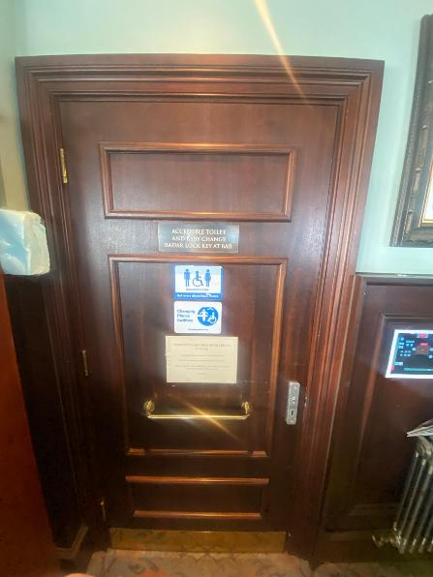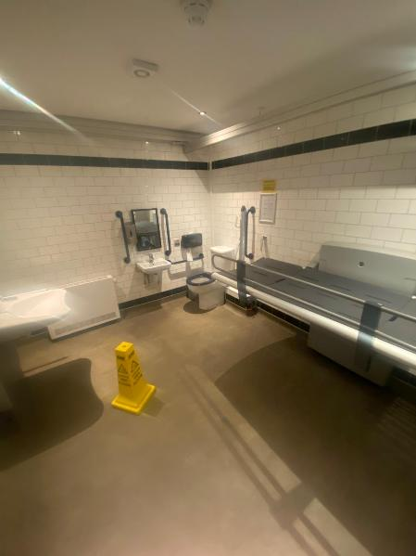

Route Description

Loop 1 – The Royal Harbour & Riviera Vibe

- Start: ///remedy.vivid.stiff, Harbour Parade (CT11 8LN)
- Distance: 1.4 miles
- Duration: 45 minutes
- Loop 1 begins on the corner of Harbour Parade opposite Yacht Marina. Make your way from here along Harbour Parade towards the Clock Tower:
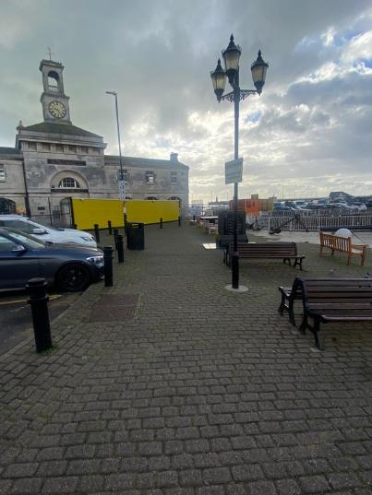
where two important WW2 operations launched from Ramsgate are commemorated. Directly beside the Tower you will find a building made from a converted shipping container that features some brilliant artwork of a tumultuous sea, and an old Steam Tug called ‘Cervia’ that was part of a restoration project by the Ramsgate Maritime Museum:
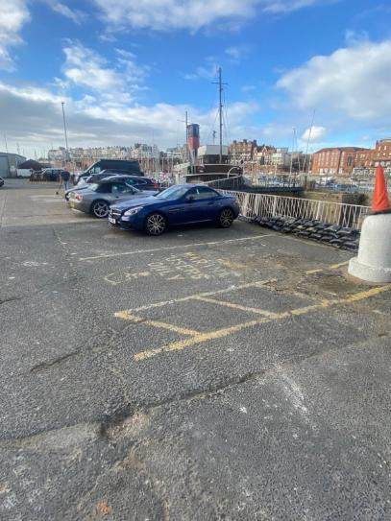
Accessibility
Varying surfaces with street furniture and other obstructions, across car parks or alongside car parks where cars may obscure the path:
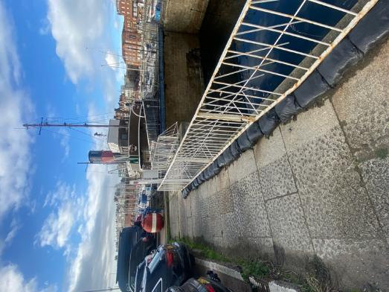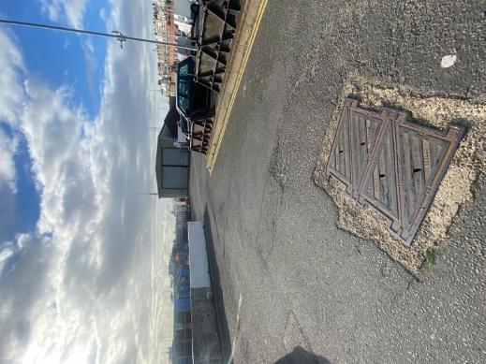
Please be aware that there are sections of this route that run alongside the water with very steep drops that do not have barriers. Extra caution should be observed in these areas.
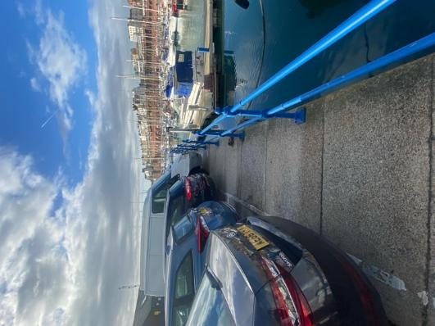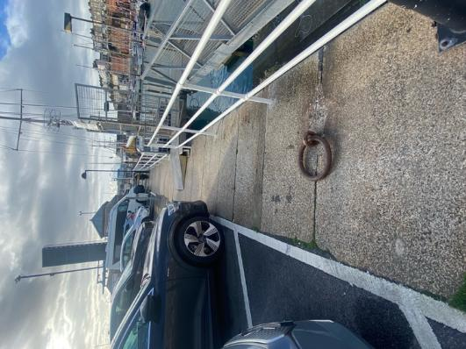

- Continue past the amenities block for the Marina (no public access) and head towards a small wooden building.
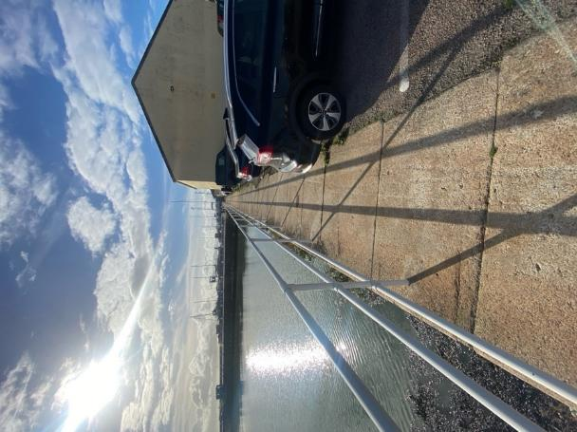
Now walk across the bridge adjacent to this building and over the channel between the Marina and Royal Harbour. You will soon pass a yacht hoist used for lifting boats in and out of the harbour, and the RNLI station to the left-hand side. Please note that the quayside is open around this loop (no barriers) so do take care of children and dogs.
Accessibility
The bridge is raised approximately 2 hours before high tide and lowered approximately 2 hours after high tide. Tide information is available from Ramsgate Royal Harbour weather and tidal Information.
The route is through a car park, with a path around the edge obscured by parked cars at either end, although okay for a short length just past the amenity building.
There are benches at the end.
- Keep on towards a large red buoy on the quayside, past another amenities block with an interpretation panel (but no public access) and follow the West Pier out to the lighthouse where, on a clear weather day, there are excellent views out towards the headland at St. Margaret’s and back towards Pegwell Bay. You’ll find a number of benches located around the base of the lighthouse that also offer some great views across the harbour to the town.
Accessibility
There are no barriers beyond the wooden building. There are benches on some of the route and a few obstructions, such as bollards to the edge. The route is uneven in places with a low edge around the lighthouse:
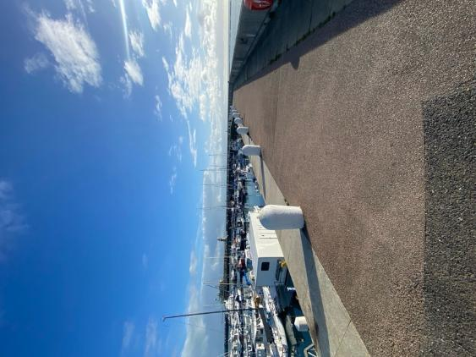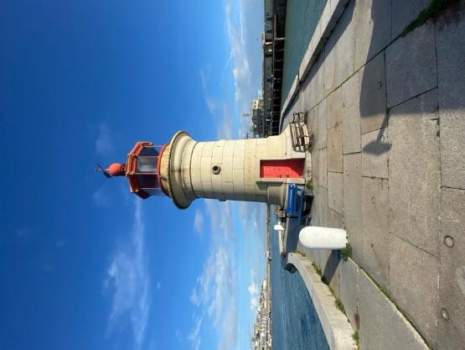
- When you are ready to continue, retrace the route back to the red buoy but carry straight on towards the Sailor’s Church. Turn right as you exit the marina gates [no gates] and on the side of the church you will see a blue plaque that commemorates the contribution of HMS Fervent to WW2.
Accessibility
There is a road crossing from the marina to the church. There is a slight incline over cobbles and immediately outside the church entrance is a brick-paved surface with a gradual incline, which presents as a small drop if approached from the church entrance on exit. There is a bench at the entrance:
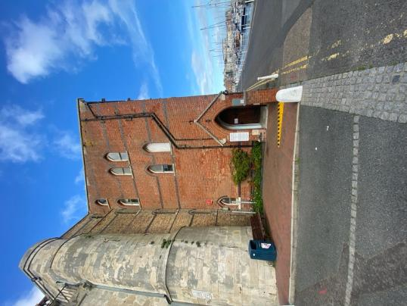
- Loop 1 has a final treat for you. Snuggled in the arches beneath Royal Parade there are a number of places to stop for a rest including ‘Ship Shape’, a small café with a delicious selection of drinks and food you can enjoy in a highly original and atmospheric setting.
Accessibility
The concrete pathway has railings alongside the water’s edge. There are intermittent bollards to the left-hand side of this concrete path:
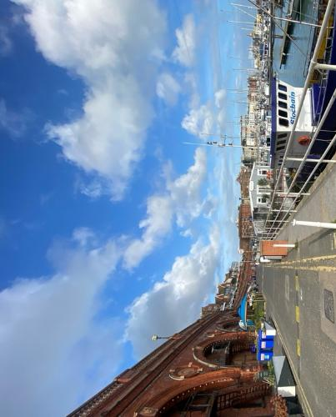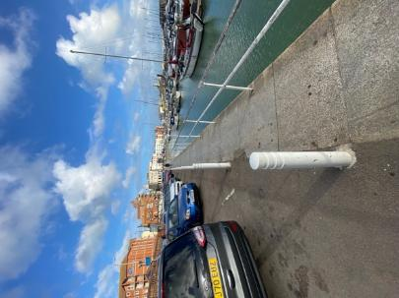

Loop 2 – Regency Elegance & Historic Homes

- Start: ///transmitted.torch.beans, Harbour Parade (CT11 8LN)
- Distance: 2 miles (3.2km)
- Duration: allow 1.5 hours
Accessibility
Please note this contains some very narrow paths and inconsistent dropped kerbs and tactile paving.
- Ready to begin Loop 2? Then cross the road opposite Harveys pub (now Mariner’s Bar):
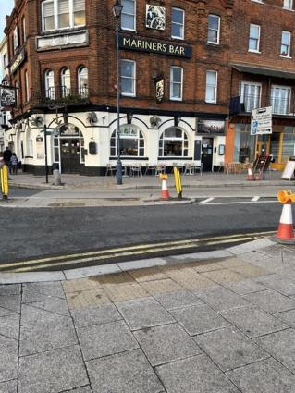
and make your way up York Street:
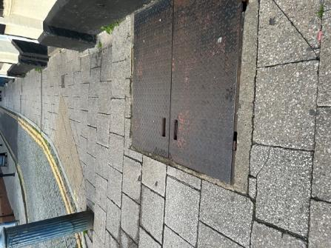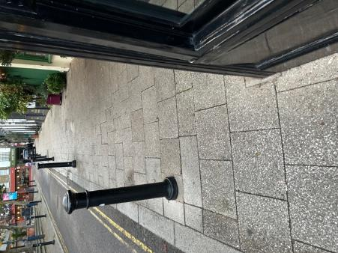
past Corby’s Tea Rooms until you reach the T-junction and turn right into Queen Street. (There are some public toilets at the end of an alley immediately to your left, if you need them (what3words ///lines.pinks.metro)).
Accessibility
For this first stage of Loop 2, there are dropped kerbs and tactile paving for key road crossings.
Although mainly paved and level, the route contains some areas with varying surface conditions, such as utility covers and service entrances. Some pathways narrow slightly where there is street furniture (such as bollards) and building projections.
- Approach the next junction with Lloyd’s bank on your left-hand side and turn into the High Street (signposted towards the post office and railway station). After 180 metres, you will turn left again into George Street, opposite NatWest Bank and the China Garden restaurant. Keep going for another 120 metres until you see a post box mounted in the wall on your right-hand side and turn into Guildford Lawn where you will be greeted by a fabulous terrace of Regency houses.

Accessibility
The surface remains paved and level (with brick and tarmac with some damaged and cracked surfaces):

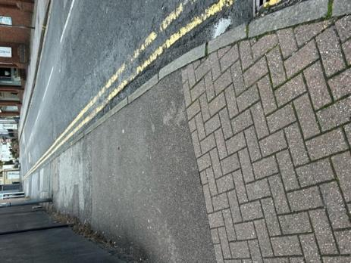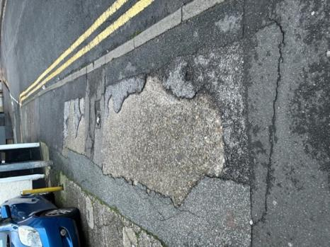

However, be aware of street furniture (e.g. shop signage boards and lamp posts that may obstruct or narrow some routes):

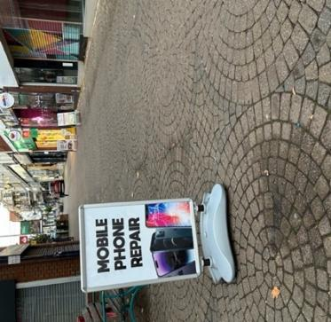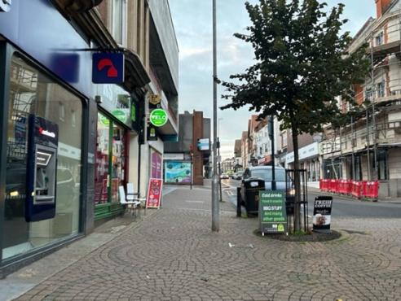
Road crossings do not have fully dropped kerbs and tactile paving:
 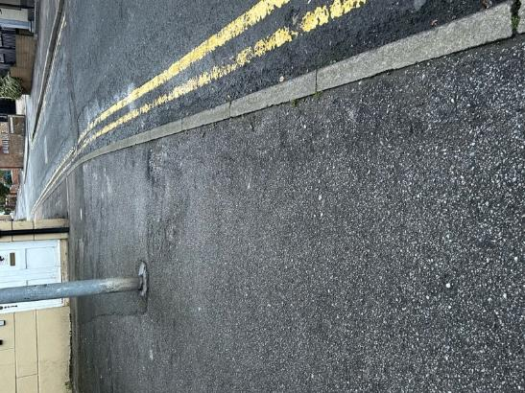
At the entrance to Guildford Lawn, there is no footpath, meaning that access is via the road:

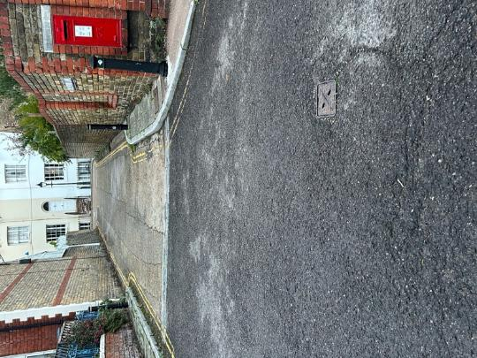
Follow the curve of the road and you will eventually emerge opposite the Public Library; a magnificent building that was restored after a serious fire in 2004. The stunning new stained-glass window you see today was produced by a local artist and incorporated designs from local schoolchildren.
Accessibility
The footpath is narrow:

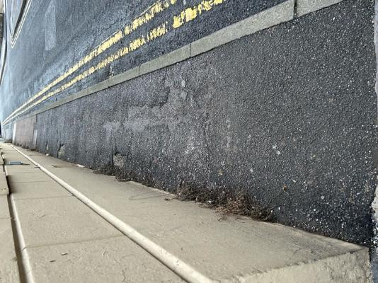

and has bollards for the first section of the curve:

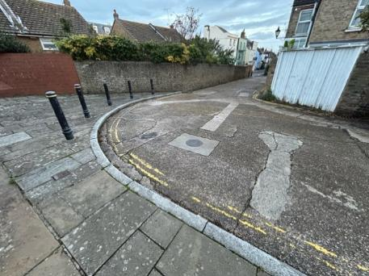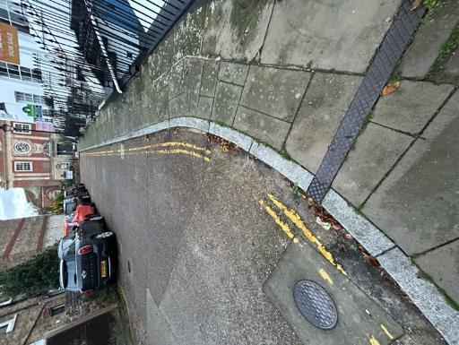

On the exit of Guildford Lawn, the footpath is completely obstructed by a bollard, meaning that you must exit onto the road via a standard height kerb, as the lower kerb is beyond the bollard; however, rejoining the footpath is further obstructed by a lamp post on the corner:

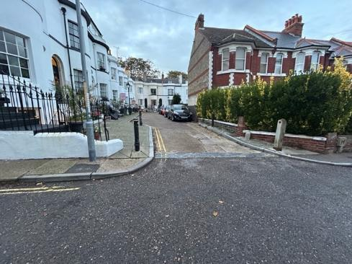

Your next turn will lead you right into Clarendon Gardens:

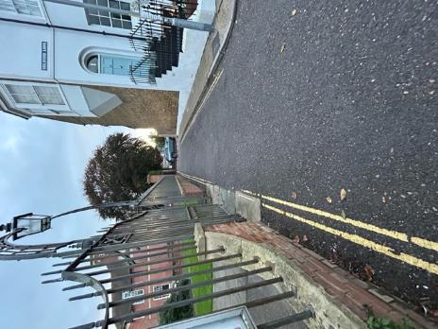

Where you will continue to follow the road to its junction with Elms Avenue. You’ll know you’re on the right track when you see the Almshouses of the Parish of St George to your right.

Accessibility
If you are unable to return to the pavement, you can follow the same route on the adjacent road, which is flat and paved with tarmac, used for access. The end of the path is uneven and very narrow, although there is a dropped kerb at the end:

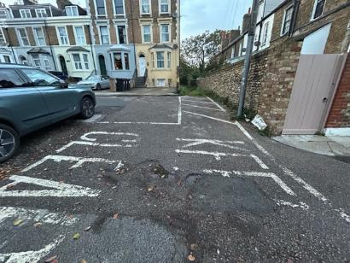

Cross the road to rejoin the footpath, which may be obscured or inaccessible because of parked cars. If this route is blocked, follow the route on the other side. However, be aware that the surface is uneven, with street furniture causing some obstruction to the path. You will also need to cross the road at the end of the path to rejoin the route.

Follow the boundary of Clarendon House Grammar School and use the pelican crossing to cross over to Beresford Road on the right-hand side. At the end of Beresford Road turn left into Vale Square and walk towards the fenced park/shared garden that’s directly ahead of you on the right-hand side. Now turn right and, keeping the park to the left (you are still in Vale Square), make your way down this leafy lane towards the spire of Christchurch Church. Turn left past the front of the church, following Vale Square round which will bring you to back on yourself to a junction with Vale Court. Turn right here and head towards the Artillery Arms pub on the opposite side of West Cliff Road:
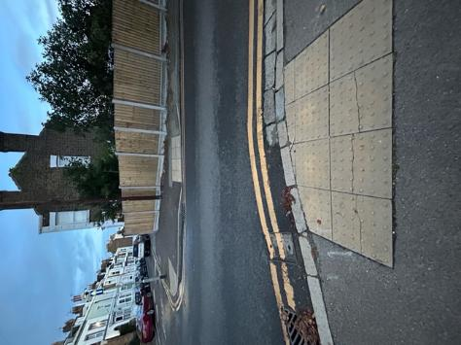
Accessibility
The road crossing is via a pelican crossing (with tactile paving and a dropped kerb):

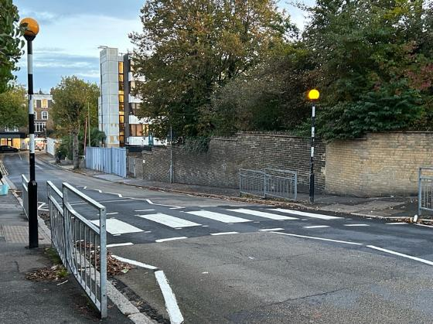
This section contains narrow paths with varying surfaces where roads need to be crossed where there are inconsistent dropped kerbs and no tactile paving. Please note that cars often obstruct the route causing it to narrow in places where wheelchairs may not be able to pass:

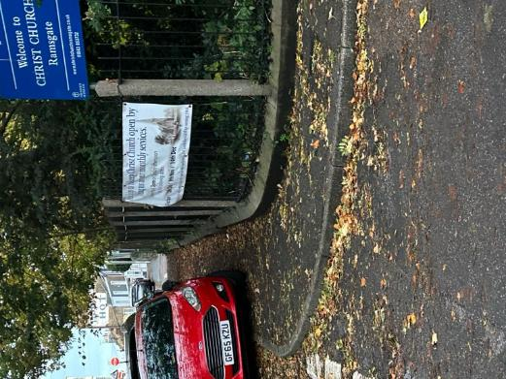

- Continue over West Cliff Road into Royal Road and head towards the prominent sign for the Trafalgar Hotel painted on the side of a tall building. You might want to pause for a while to enjoy everything Spencer Square has to offer at this point. As well as the historic terraced houses overlooking the square there is a small park (with plenty of benches for weary walkers), a couple of tennis courts, and two blue, circular plaques commemorating the homes of Vincent Van Gogh (1876) and local author and editor, John-Gibson Lockhart, (who was also the son-in-law of the author Sir Walter Scott).
Accessibility
This section contains narrow paths with varying surfaces where roads need to be crossed where there are inconsistent dropped kerbs and tactile paving. Please note that cars often obstruct the route causing it to narrow in places where wheelchairs may not be able to pass.
There are benches in Spencer Square for rest stops and well surfaced routes suitable for wheelchairs and no width restricting features.
There are blue plaques in Spencer Square:
Vincent Van Gogh
1853-1890
Painter
lived here
1876.
THE RAMSGATE SOCIETY
JOHN GIBSON LOCKHART
1794–1854
Author, Editor of
The Quarterly Review
Son-in-law of author
Sir Walter Scott
Lived here

- Cross over into St Augustine’s Road and pass the Regency Hotel on your left shortly before reaching the historic St Augustine’s Abbey and Gothic church designed by Pugin, to the right-hand and left-hand side of the road respectively. Both historic buildings are easily recognisable by their flint-stone construction. A little further on and you will turn left, pass the public conveniences (with baby-change and disabled facilities) and head towards West Cliff Promenade and the Lookout kiosk where you can grab a well-deserved drink or snack, choose a bench and enjoy some fabulous views across the Western Ferry Terminal to the Royal Harbour.
There are plenty more opportunities to sit on a bench and take in the view, as you bear left onto the West Cliff promenade and continue back towards the Harbour.
Accessibility
The promenade section has a very flat, wide and even surface. However, the path is shared with bicycles:

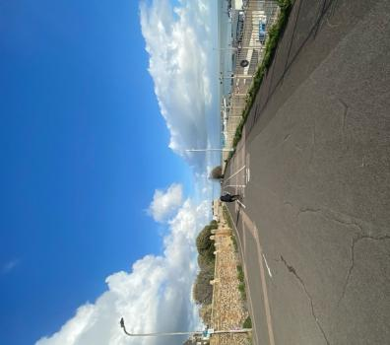
- As you pass the Churchill Tavern, the promenade runs alongside the road and, approximately 165 metres on from the pub, cross over the road to enter Nelson Crescent. Now follow the road into Prospect Terrace until you reach the Foy Boat public house [no longer a public house] and bear left into Liverpool Lawn – famous for its Regency style houses and named after Earl Liverpool, Lord Warden of the Cinque Ports and Prime Minister 1812-1827.

Accessibility
The promenade section has a very flat, wide and even surface. However, the path is shared with bicycles. There is a wide road before Nelson Crescent with no dropped kerb or official crossing such as an accessible pedestrian signal (APS), so caution is advised:
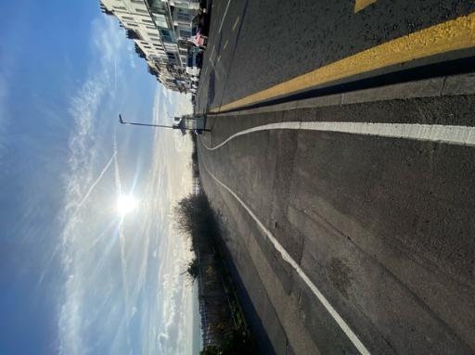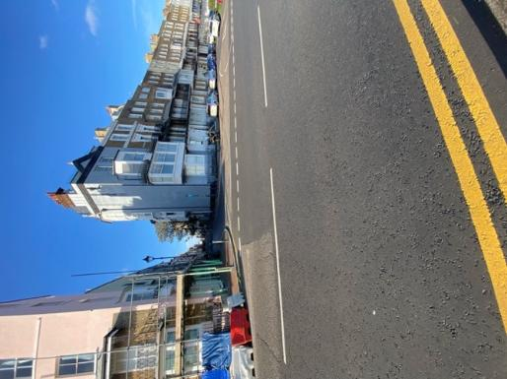
This section contains narrow paths with varying surfaces where roads need to be crossed where there are inconsistent dropped kerbs and tactile paving. Please note that cars often obstruct the route causing it to narrow in places where wheelchairs may not be able to pass.

- Walk on a little further, keeping the ‘Lawn’ on your right, until you turn into a smaller lane and Adelaide Gardens. From here you will emerge at a T-junction opposite a house with a blue plaque that records the birthplace of Sir William Jordan, the New Zealand High Commissioner. Turn left and then almost immediately right into Albert Street and make your way towards some modern apartments. Turn left into Grundy’s Hill and you will see Waitrose supermarket at the bottom of the hill on the opposite side of Queen Street. Take the right turning into Queen Street and continue for approximately 175 metres, crossing over Cliff Street, Princes Street and Leopold Street en-route. Follow the fourth turn on your right, into York Street and after approximately 30 metres you will reach Charlottes Court, a small alley on your left situated directly opposite the Sunrise Café.

Accessibility
This section contains narrow paths with varying surfaces where roads need to be crossed where there are inconsistent dropped kerbs and tactile paving. Please note that cars often obstruct the route causing it to narrow in places where wheelchairs may not be able to pass.
Benches available in Liverpool Lawn.
Blue plaque text – The Ramsgate Society. Sir William Jordan, P.C., K.C.M.G. 1879-1959. New Zealand High Commissioner in London. Born here.
In York Street there is a raised area to the right of the footpath that graduates to steps to a parade of shops. In addition, there is street furniture such as bollards and lampposts to be aware of. There are benches available in this section.
- Follow Charlottes Court past a selection of pubs including Age & Son [closed], The Horse and Groom and The Harbour Street Bar until you exit opposite the Village Grill where you will turn right into Harbour Street, follow the road back down to the Yacht Marina and end the walk right back where it began; outside The Royal public house where you can celebrate your success with a glass of your favourite tipple.

Accessibility
Cross the York Street to access Charlotte’s Court. This is level access. There is a bollard immediately at the entrance to Charlottes Court.
This section contains narrow paths with varying surfaces including a small, cobbled section where there are commercial waste bins which may cause some obstruction to routes:
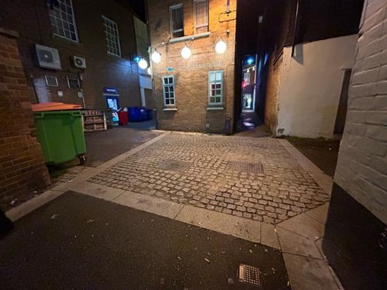

The final section in Harbour Street contains more narrow paths with varying surfaces where roads need to be crossed; there are inconsistent dropped kerbs and tactile paving. Please note street furniture often obstructs the route causing it to narrow in places where wheelchairs may not be able to pass without exiting into the adjacent road:
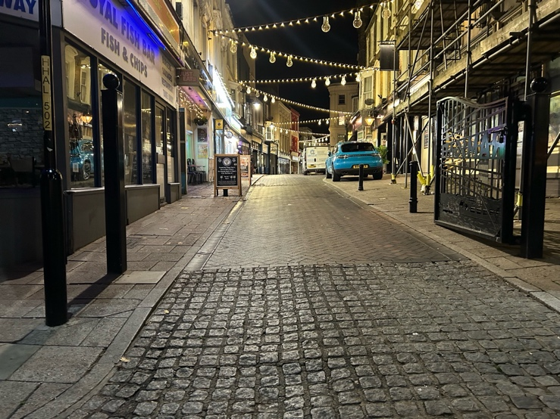
For more walks in Kent use the excellent Explore Kent website www.explorekent.org Download the Explore Kent App and follow this walk on your smartphone.
This document for this walk is available in alternative formats and can be explained in a range of languages. Tel: 0300 333 554

