Minnis Bay to Reculver Country Park accessibility guide
Table of Contents
Minnis Bay to Reculver Country Park accessibility guide 1
About this Guide 2
Google Maps 360 View 2
How to use what3words 2
Overview 3
Accessible Parking 3
Accessible Toilets 5
Route Description 10

About this Guide
This accessibility guide is an accompaniment to the following guides, which describe the route:
- Minnis Bay to Reculver Country Park Stile Free Trail - Explore Kent
- Walks For All 2 – Minnis Bay
This guide provides an overview of accessibility features and potential barriers along the route. While we have highlighted key considerations, it is not possible to include every example of every barrier. Please take care and plan thoroughly before setting out, especially at different times of the year when conditions, surfaces, and access to facilities may change. The route is shared with cyclists and joggers, so extra care is always needed. As the route follows the coastline, weather can be changeable, so it is advisable to check the local forecast before beginning your journey. Some sections may include hazards such as low walls, steep drops, and areas near water, so caution is always required.
If you would like to convert this guide into an alternative format, RoboBraille is a free service that converts documents into accessible formats, including audio, Braille, and e-books.
My Computer My Way is an online guide by AbilityNet that helps people customise their devices for better accessibility, offering step-by-step instructions for Windows, macOS, iOS, Android, and browsers.

Google Maps 360 View
To learn more about the surroundings along this walk, you can explore the 360 degree Google Map for Charles III England Coast Path Minnis Bay to Reculver. This resource provides a good sense of the landscape and features you’ll encounter.

How to use what3words
As recommended by the Royal National Institute of Blind People (RNIB), key locations have been given using what3words. what3words is a global addressing system that divides the world into a grid of 3m x 3m squares, assigning each square a unique combination of three words to make locations easy to find and share.

Get the App or Website
- Download the what3words app (iOS/Android) or go to what3words.com.
- Find Your Location
- Use the map or search bar to find where you are or where you want to go.
- Zoom in and tap the exact spot.
- Get the 3-Word Address
- Each 3m x 3m square has a unique address like ///apple.orange.banana
- Navigate
- Tap “Navigate” to open directions in Google Maps, Waze, or other apps.
- Share
- Copy the three words and share them via text, email, or social media.

Overview
Follow the King Charles III England Coast Path (KCIIIECP) and take in the wonderful sea views of the Thanet Coast. The length of the route is flat, making this stile-free route suitable for pushchairs and wheelchairs.

The walk also follows the Viking Coastal Trail.
- Location: Start at CT7 9QP
- Distance: 3.7 mi (5.95 km) linear walk
- Explorer Map: 150
- Parking: Minnis Bay Car Park located at The Parade.
- Refreshments and Facilities: A selection of eateries and accessible public toilets at Minnis Bay and Reculver.
- Public Transport: Train services to and from Birchington-On-Sea. Stagecoach South East buses run towards the start of the route. Check Kent Connected to plan your journey.
Accessible services and facilities for visitors to Margate, Broadstairs and Ramsgate
- Accommodation.
- Accessible Beaches and Bays.
- Car Parking and Public Transport.
- Mobility Hire and Services.
- Public Conveniences.

Accessible Parking
Below are car parks that are most closely related to the route. A full list of car parks, accessibility information, opening times and charges can be accessed via Thanet District Council’s Accessibility Information webpage and Further information about accessible parking spaces, opening hours and charges.
Minnis Bay Car Park
- 154 spaces, 9 accessible bays (7 opposite the toilets and 2 adjacent to the toilets)
- what3words: ///professed.bridges.carpeted

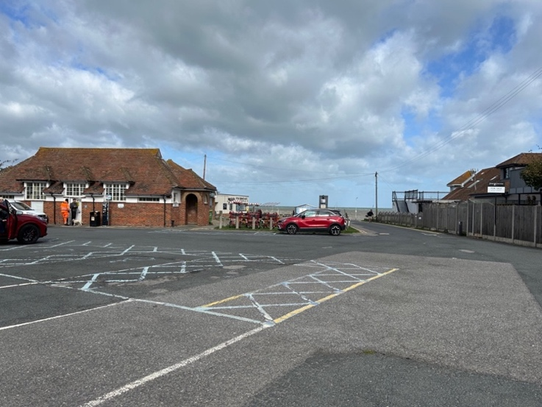
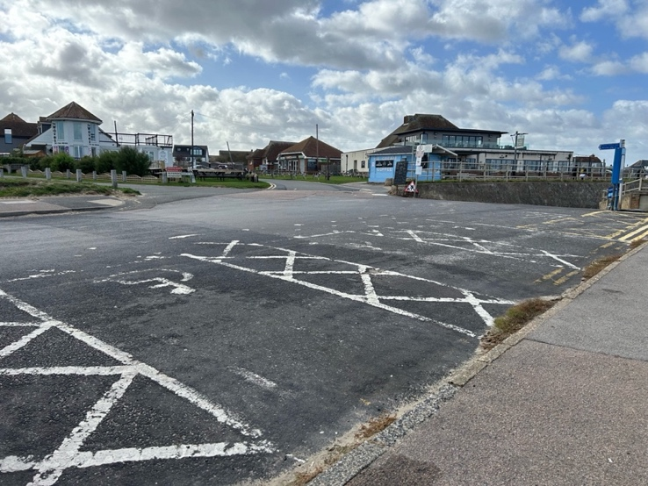
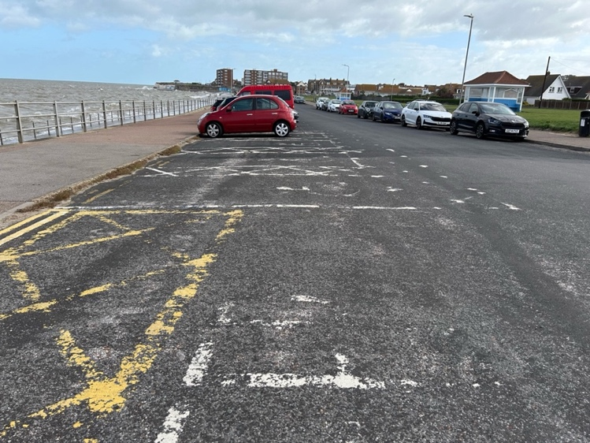
- There are 4 additional accessible bays on the road opposite, next to the seafront, what3words: ///chop.samplers.ballots

Reculver Country Park Car Park
- 78 spaces, 2 accessible bays
- what3words: ///diagram.exists.clattered

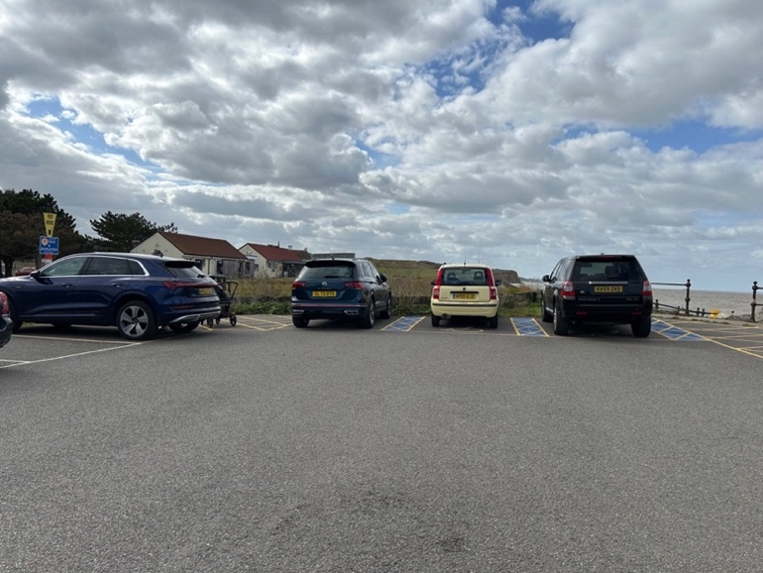

Accessible Toilets
Below are toilets that are most closely related to the route. A full list of toilets in the area including accessibility information and opening times can be accessed on Thanet District Council’s Information about public toilet facilities in Thanet.

Minnis Bay Toilets
- what3words: ///slyly.solves.slang
- RADAR key required.
- Right-hand transfer
- From the accessible parking bays, the accessible toilet will be directly ahead of you as you head towards the seafront, accessible by a ramp to the right-hand side. Immediately in front of the entrance there is a metal railing so access must be via the ramp.
- It is worth checking the door, which may appear to be padlocked/bolted, as it may be opened with a RADAR key. A key is available at Honey’z Beach Bar next door. Note the path to Honey’z and The Minnis Bay Bar & Brasserie is narrow and uneven, with bins projecting into the path.
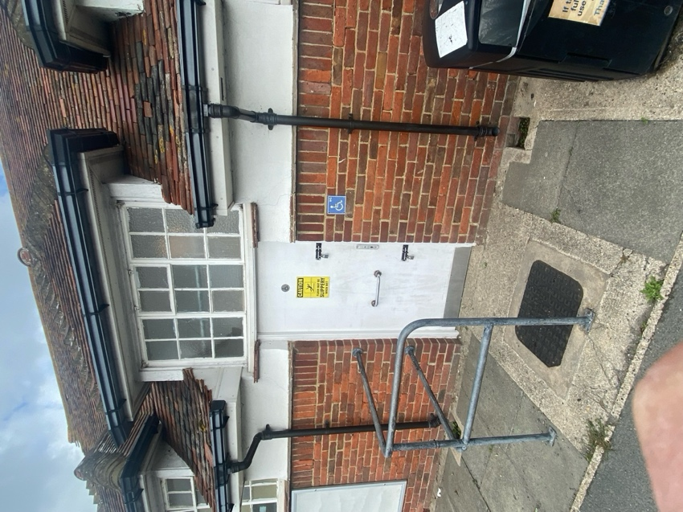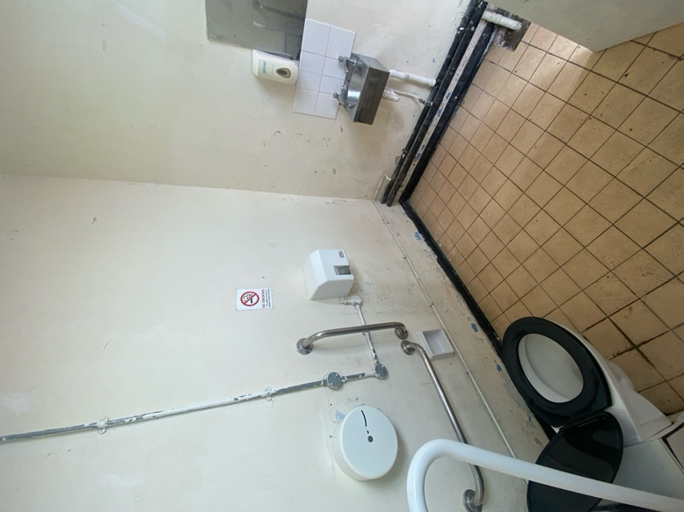

- There is also an accessible toilet within The Minnis Bay Bar & Brasserie
  - what3words: ///strapped.gambles.diverting
  - Right-hand transfer

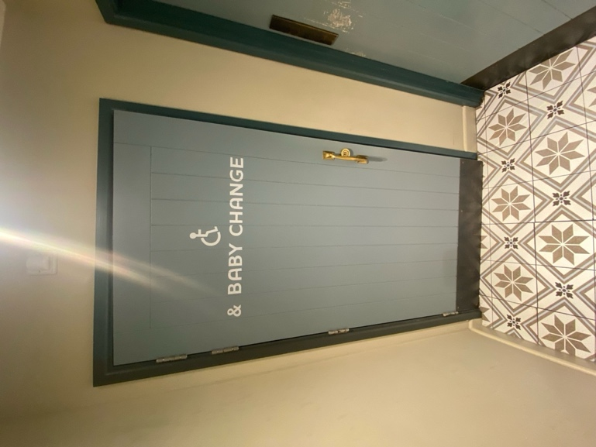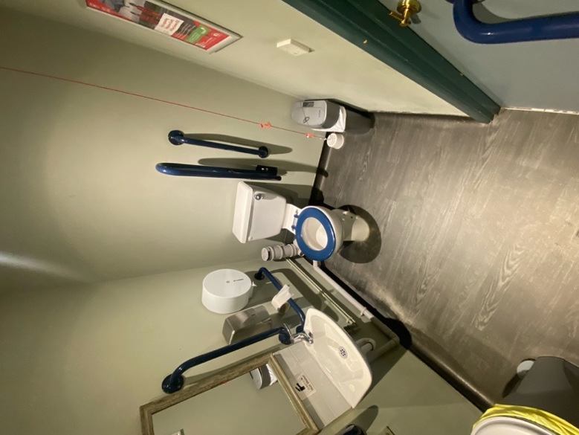

Reculver Visitor Centre Toilets
- The toilets are located adjacent to the car park on the approach to HatHat’s café
- what3words: ///multiply.famines.standards
- RADAR key required.
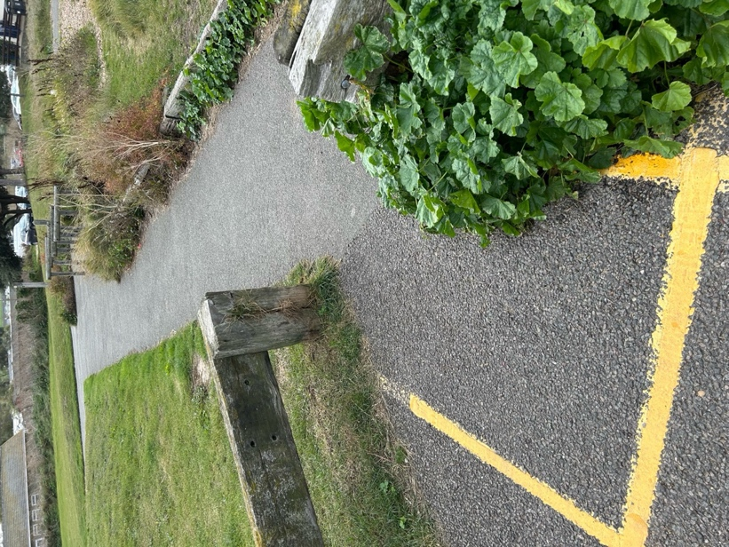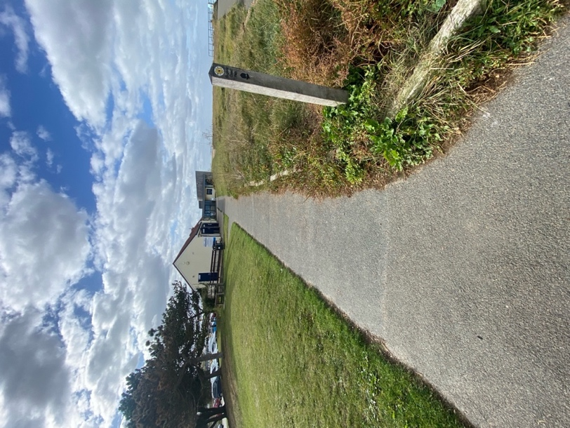
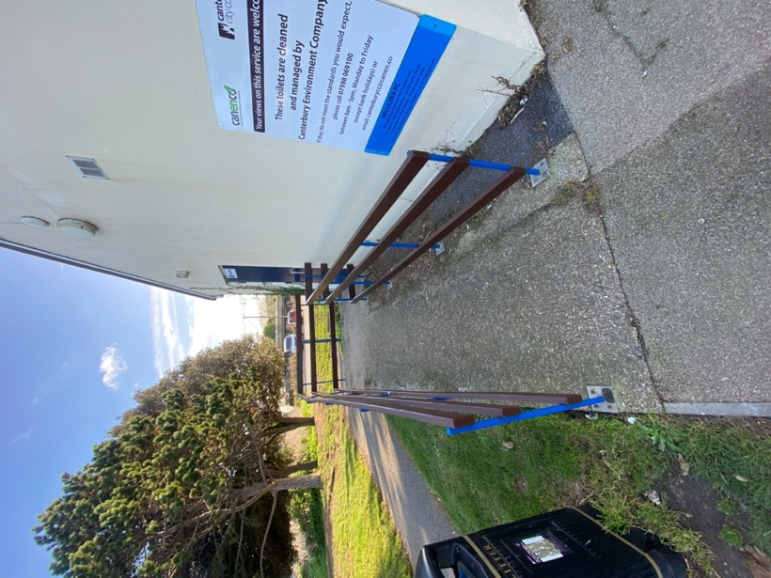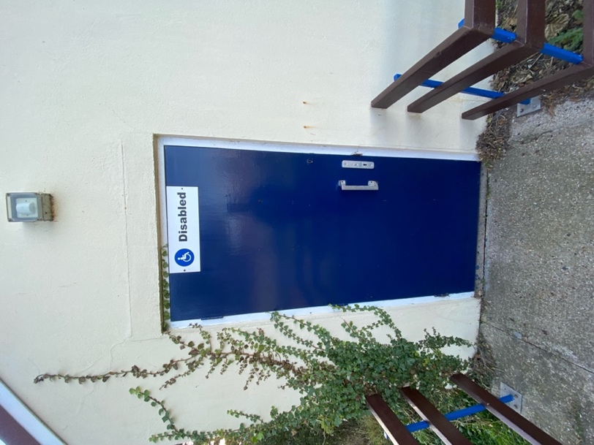
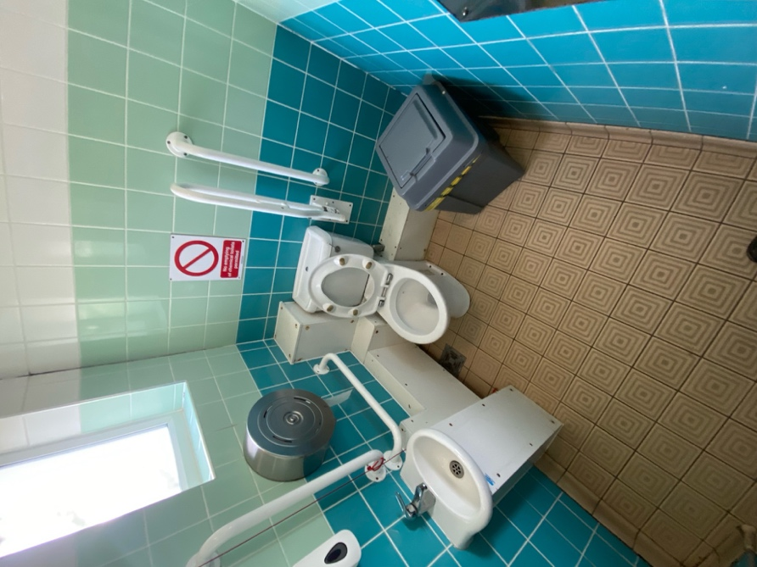

Changing Places
- Reculver Country Park Visitor Centre
- what3words: ///multiply.famines.standards
- RADAR key required

- Bench - Height Adjustable, Adult Sized, Wall Mounted
- Hoist - Ceiling, Loop
- Peninsular Toilet
- Washbasin Height Adjustable
- Slip Resistant Floor
- Floor Space (sq. m) - 18.0
- Emergency Alarm
- Privacy Screen
- Paper Roll
- Colostomy Shelf
- Drop down grab rails
- Wall grab rails
- Large Bin
- Door Width (m) - 1.00
- Ceiling height (m) - 2.00
List of toilets which have accessible facilities.
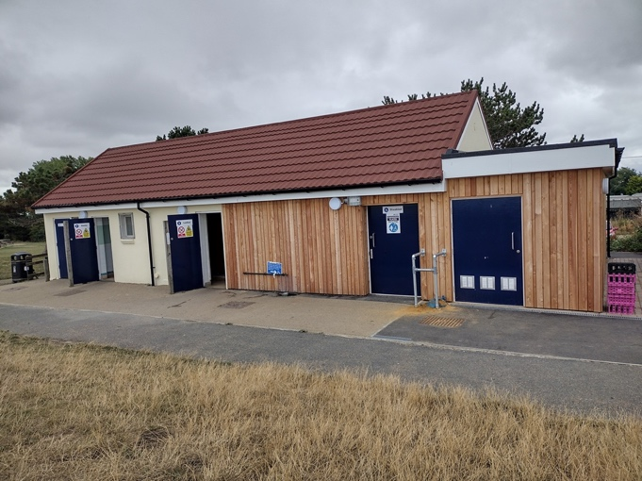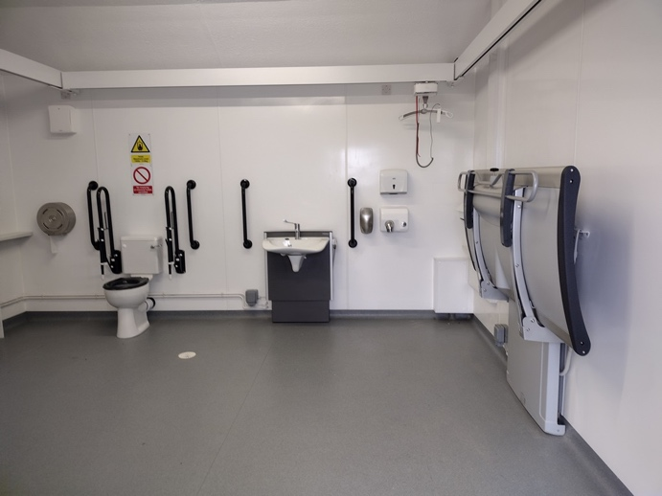

Route Description
- Take the path from the corner of the car park heading towards Reculver. The path is marked by a blue sign indicating cycle route 15. Take this path and continue until you reach the 1st barrier.
- Continue walking along the path on the sea wall for 2.8 miles (4.5km), towards Reculver Towers.

Accessibility
From the car park, there is level access to the trail start, marked by a blue Cycle Route 15 sign [obscured with stickers].There is a bollard in the centre of the path at the start. The surface is hard and even, mostly concrete/tarmac, with a minimum width of 1.2 m and generally flat.
Users should be aware of shared use with cyclists and potential weather-related surface hazards. The initial path runs along a concrete/tarmac-surfaced sea wall, maintaining the same width, with an incline of 4% as it nears Reculver. Sightlines are clear, and benches are conveniently positioned near the start, including a shelter. There is no barrier on the seaward side near the beginning.
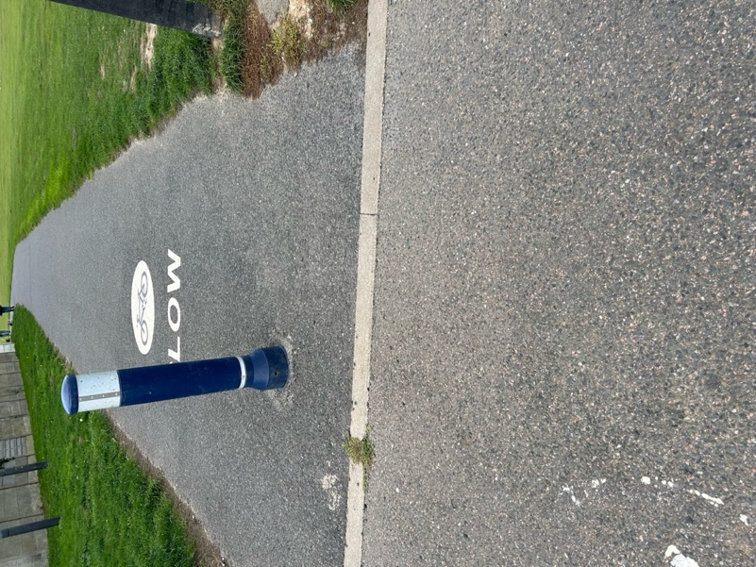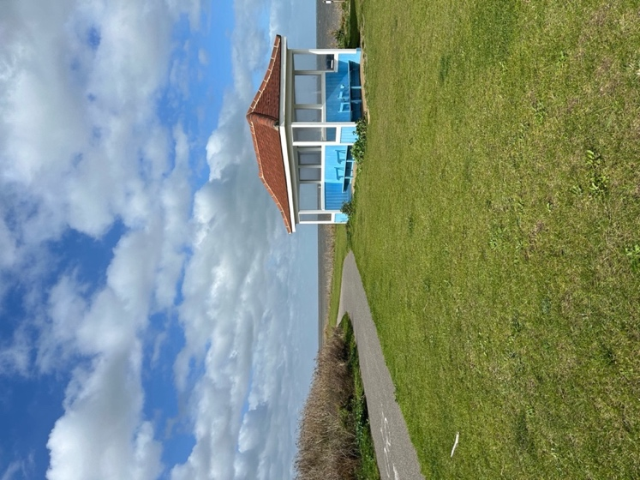

There are frequent steps that lead to the beachfront, where a path alongside the shingle beach runs partially parallel. The steps have railings on one side. Please be aware that from the beach may cover the lower path entirely. There is no wheelchair access to the lower path. This is not part of the route:
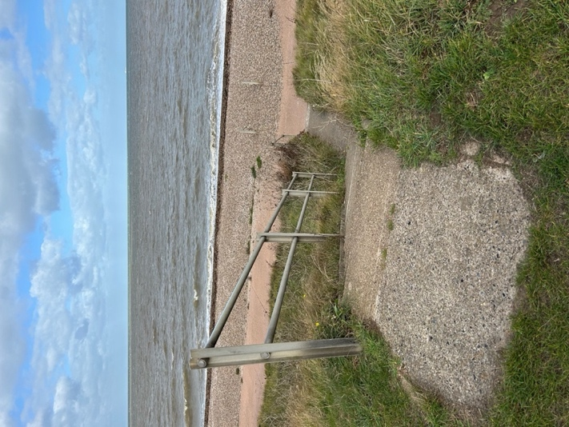
The 1st barrier has Environmental Agency signs stating:
- Caution, vehicles regularly access this route.
- Hazards present in this area.
- Sudden drops.
- Slippery surfaces.
- Uneven surfaces.
- what3words: ///:carefully.quite.glades
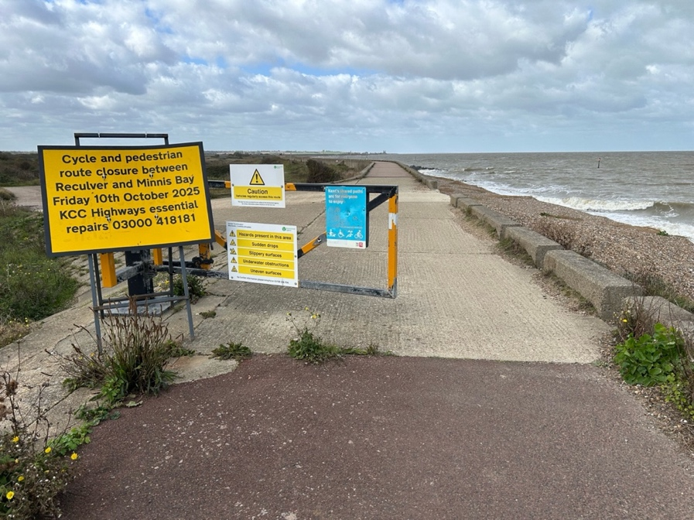
Accessibility
Examples of the surface and path edges are shown below. Given the location, there is also the risk of shingle at various points on the route.
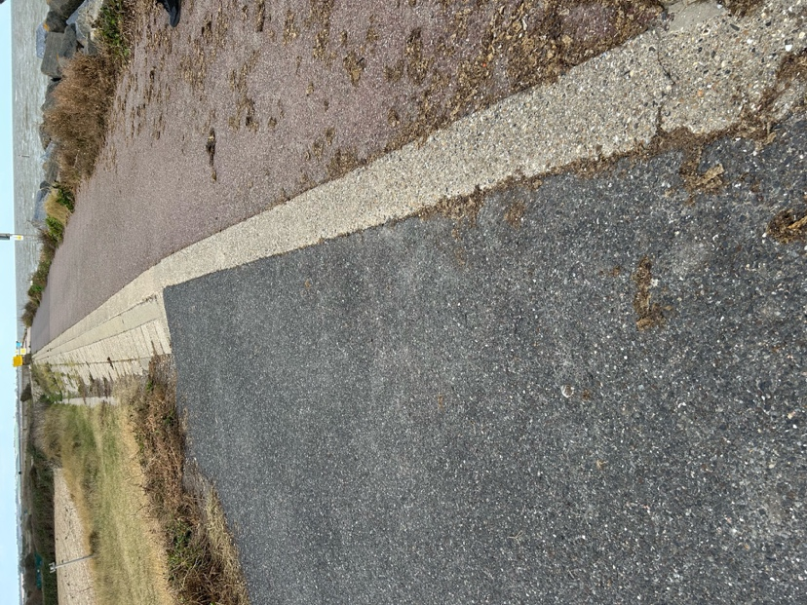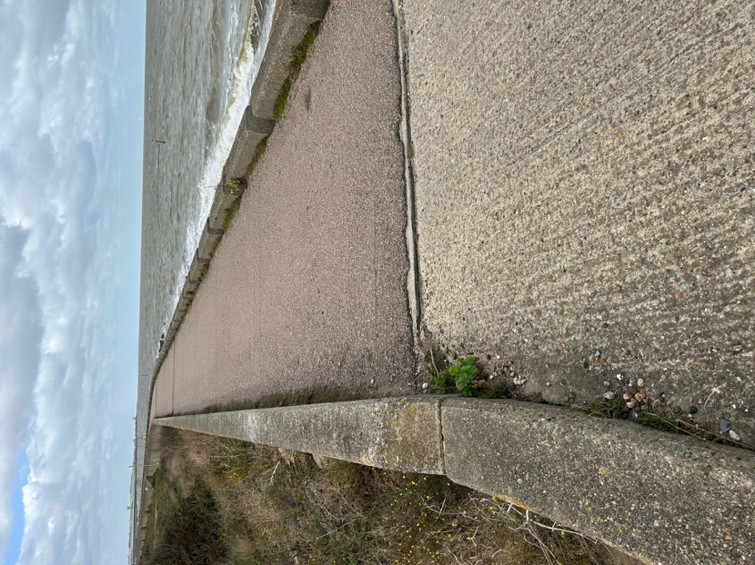
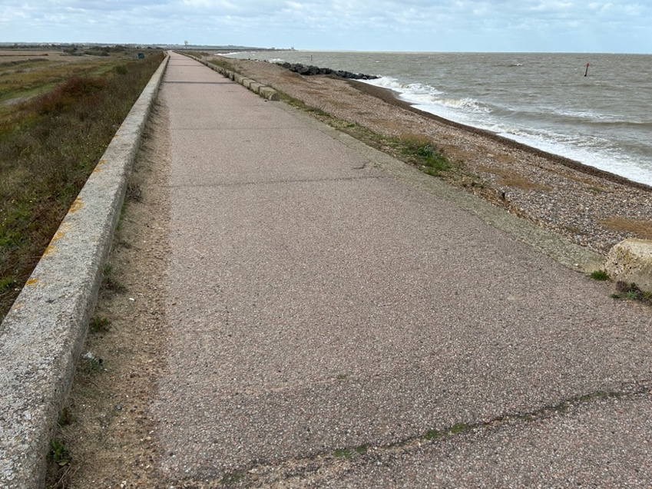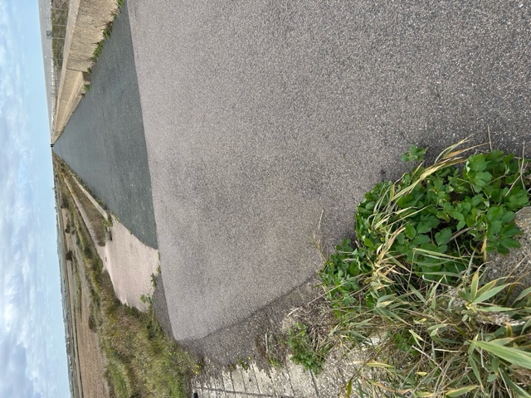
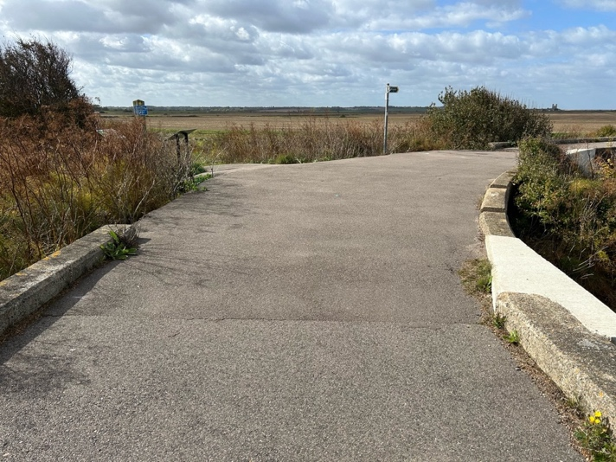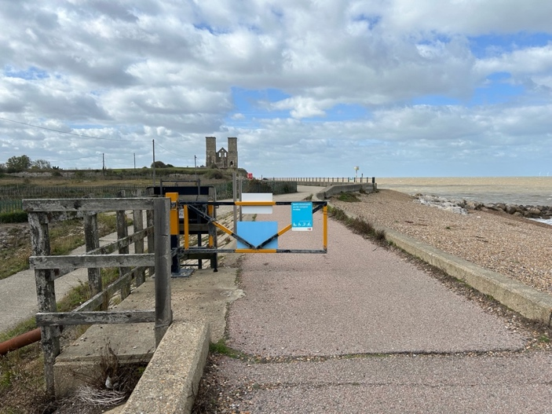
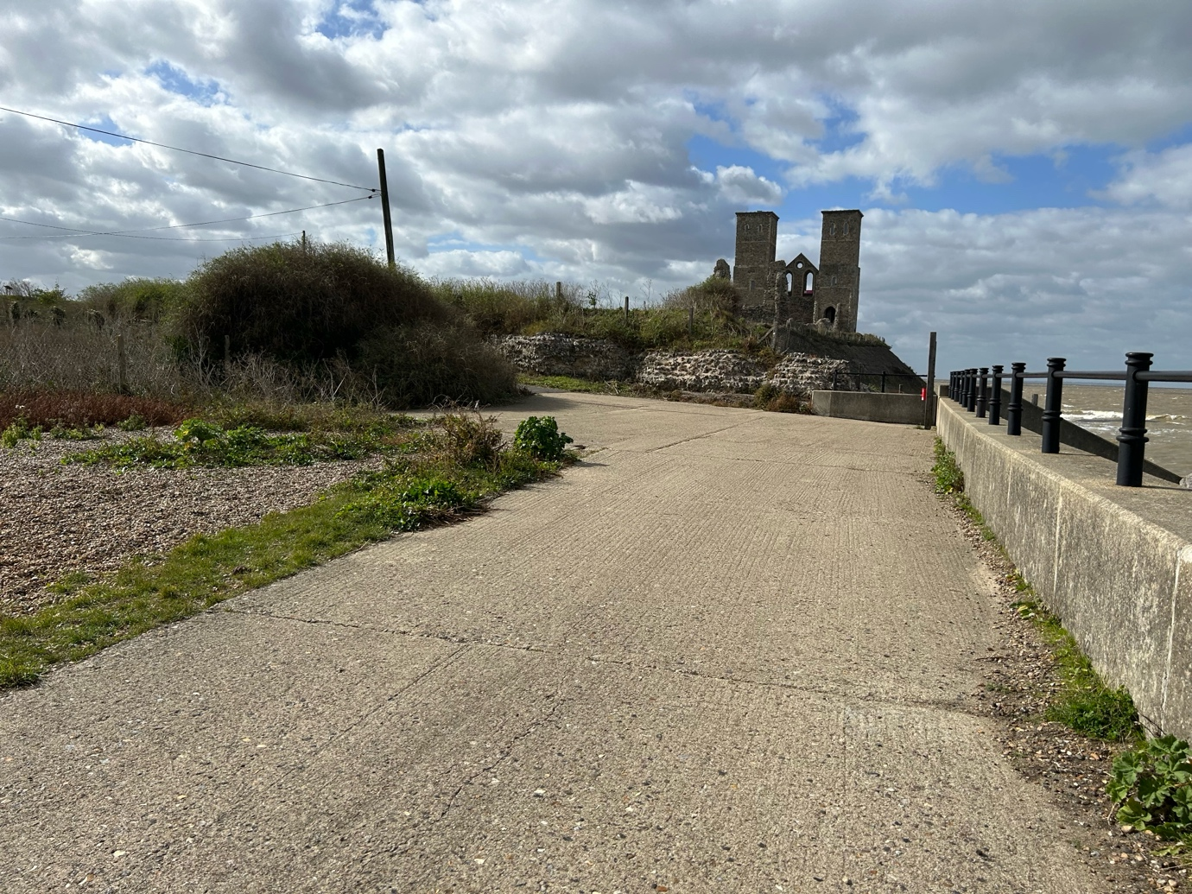
Points of interest

- Salt Water Lagoon: Here a bend in the sea wall and a shingle ridge has created a sheltered area with a salt-water lagoon. Sea Pursland, Sea Beet and Saltmarsh Rush grow on the clay and shingle banks.
- Plum Pudding Island Lagoon
- Oyster Farm
- Reaching the narrow path on the right, continue straight ahead. The path widens and becomes a disused road.

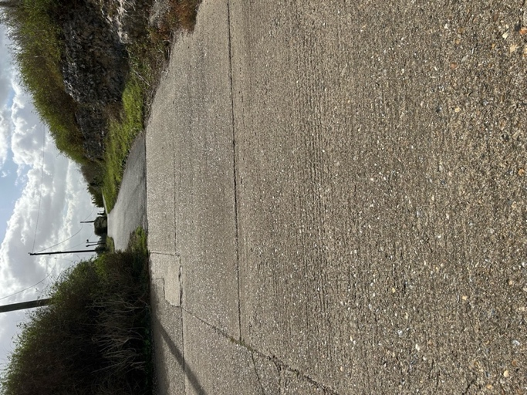

- Alternatively, you can follow the steep climb to Reculver Towers and then descend to reach the car park.

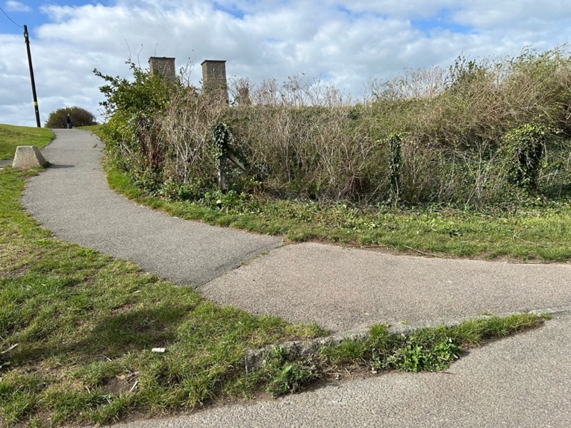

Accessibility
The alternative route to Reculver Towers involves a steep 12% climb and 25% descent from the Towers to the car park:

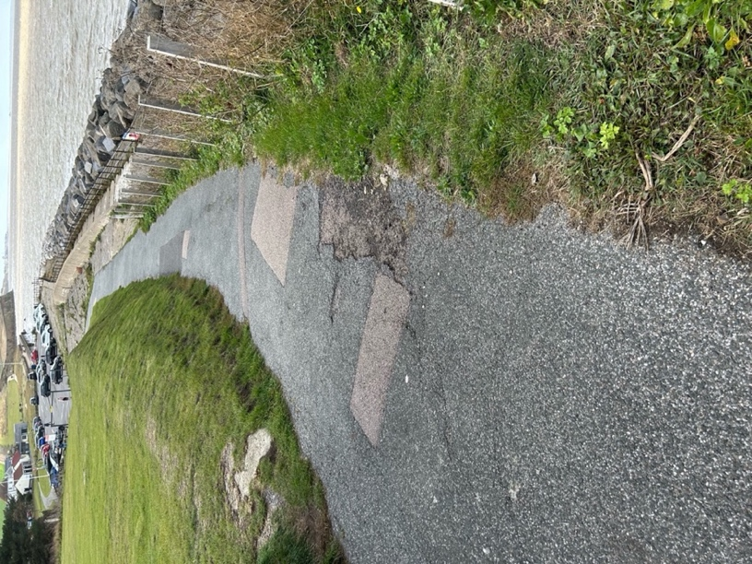
- The road ends in a 5-bar metal gate with a passing place on the right-hand side, next to the King Ethelbert Inn.

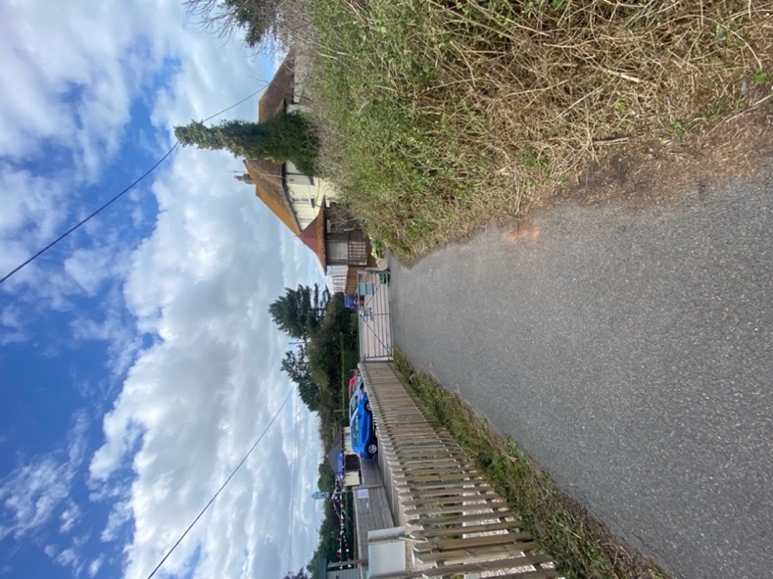
Take care crossing the road and continue ahead to reach the car park and visitor centre. You can finish the walk here or retrace your steps back to Minnis Bay.
Reculver Towers and Fort
Romans built a fort at Reculver two thousand years ago to guard the channel separating the Isle of Thanet from Kent. More than half of the fort has been washed into the sea, but the southern and eastern walls remain. The twin towers of Reculver are the remains of a medieval church.

Accessibility
Please be aware that there is no level access path to the fort itself, which is situated on grass with low walls and obstructions.
English Heritage warn of slip hazards, trip hazards, steep slopes and sheer drops.
English Heritage: Reculver Towers and Roman Fort

Facilities at Reculver include public toilets, an accessible HatHats Coffee Shop for refreshments; there is a push-button door opening and level access throughout.
The seating areas may be quite noisy during busy periods, and furniture may need to be rearranged to allow access to all areas.
There are accessible picnic benches with spaces for wheelchairs, and the park has an accessible swing and roundabout.

HatHats: The old visitor centre was turned into this coffee shop in 2017, complete with a Coastal Classroom. This is an educational space for schools and community events:
